Advanced Computer Vision-Based Retail Analytics: A Novel Approach to Customer Behavior and Product Movement Tracking
Saumil Patel, Rohith Naini
Abstract ID: 6883
Abstract
This study presents a prototype computer vision-based retail analytics system implemented in a controlled laboratory environment with commercial deployment validation. Our System Performance Index (SPI) framework achieved over 90% customer-product tracking accuracy with real-time processing at 25 FPS per camera. The prototype demonstrated significant operational improvements, including 42% reduction in congestion points and 31% improvement in staff utilization. The research advances retail analytics through quantifiable metrics for operational efficiency while addressing industrial engineering challenges in retail operations..
Keywords: Computer vision, retail analytics, multi-camera tracking, customer behavior analysis, operational efficiency.

Introduction
The retail industry faces annual losses exceeding $642 billion due to inefficient operations and suboptimal customer experiences. Traditional methods relying on point-of-sale systems and manual counting fail to capture crucial metrics including customer paths, product interactions, and real-time inventory levels [1]. Our research presents an industrial engineering approach that leverages synchronized multi-camera systems and advanced object detection algorithms to provide comprehensive retail intelligence [2].
This research addresses fundamental challenges through the development and validation of a synchronized multi-camera tracking system, with successful implementation at a retail location in Beaumont, Texas. Initial results demonstrate significant improvements in operational efficiency, including 31% enhancement in staff utilization and 47% reduction in checkout wait times through optimized queue management.

Problem Description
Contemporary retail analytics solutions face three critical challenges that directly impact operational efficiency. First, accurate simultaneous tracking of customers and products requires sophisticated real-time computer vision capabilities, traditionally requiring extensive manual observation and time-motion studies. Second, multi-camera systems must maintain precise synchronization while processing high-resolution video streams, a significant departure from traditional single-point observation methods. Third, the system must integrate seamlessly with existing retail infrastructure while ensuring customer privacy and data security [3].
The industrial engineering implications of these challenges are substantial. Traditional time-motion studies, typically requiring 120-160 hours of manual observation, can be automated and conducted continuously. Resource allocation decisions, previously based on periodic sampling, can now be optimized in real-time using comprehensive movement and interaction data.

Related Research
Recent advances in computer vision and retail analytics have established foundations for our research. Hui et al. [1] demonstrated the importance of in-store travel patterns in understanding customer behavior. Bradlow et al. [3] established frameworks for big data analytics in retail environments. Building upon these works, Nogueira et al. [4] [3] [2]. introduced deep learning approaches for customer tracking and hotspot detection.
Our research extends these foundations through enhanced tracking algorithms and comprehensive system integration. We build upon the SORT algorithm [5], incorporating appearance features for improved tracking consistency in crowded scenes.

Methodology

System Architecture
The system employs an integrated approach combining computer vision capabilities with industrial engineering principles. Four strategically positioned cameras provide comprehensive coverage while minimizing redundancy and operational complexity. The novel System Performance Index (SPI) quantifies operational effectiveness through:
The core innovation lies in our novel System Performance Index (SPI):
SPI = α(DA × PA) + β(PS/PSmax) + γ(RU/RUmax)
Where:
DA = Detection Accuracy (0-1)
PA = Processing Accuracy (0-1)
PS = Processing Speed (FPS)
RU = Resource Utilization (%)
α, β, γ = Optimization coefficients
Through Monte Carlo simulation (10,000 iterations), we determined optimal coefficient values: α = 0.45 (±0.02), β = 0.30 (±0.02), γ = 0.25 (±0.02)
This metric provides a comprehensive measure of system performance, integrating multiple operational parameters into a single quantifiable index [6].

Implementation Framework
The system implementation architecture consists of three interconnected layers that work in concert to deliver comprehensive retail analytics capabilities. The Acquisition Layer forms the foundation, incorporating four synchronized high-definition video feeds operating at 1920×1080 resolution with 30 frames per second. These feeds maintain precise temporal synchronization with a 33.33ms frame interval, while ensuring a minimum 30% field overlap between adjacent cameras to maintain continuous coverage across the retail space.
The Processing Layer builds upon this foundation by implementing real-time object detection through YOLOv8 architecture [7] [8]. This is enhanced by our modified SORT algorithm [5] implementation, which incorporates advanced tracking capabilities specifically optimized for retail environments. The layer culminates in a sophisticated multi-camera fusion system that generates confidence-mapped representations of the retail space and its occupants.
The Data Organization Layer manages the system's information flow through three primary mechanisms. A circular buffer system efficiently maintains recent frame data while optimizing memory usage. Spatial queries are expedited through an R-tree structure implementation, enabling rapid access to location-based information. Real-time event processing is managed through a priority queue system that ensures critical events receive immediate attention while maintaining system responsiveness.
Our research employs four specialized datasets from Roboflow Universe, carefully selected for comprehensive retail environment coverage. The Grocery Dataset (n=35,626 images) [9] encompasses 120 product categories with resolutions from 640x480 to 1920x1080 pixels, providing foundational product recognition capabilities. The 360 degree - image Liquor Dataset (n=8,500 images) specifically addresses reflective surface detection challenges through multi-angle captures under controlled lighting conditions, approach used by Patel for multimodal product detection [10].
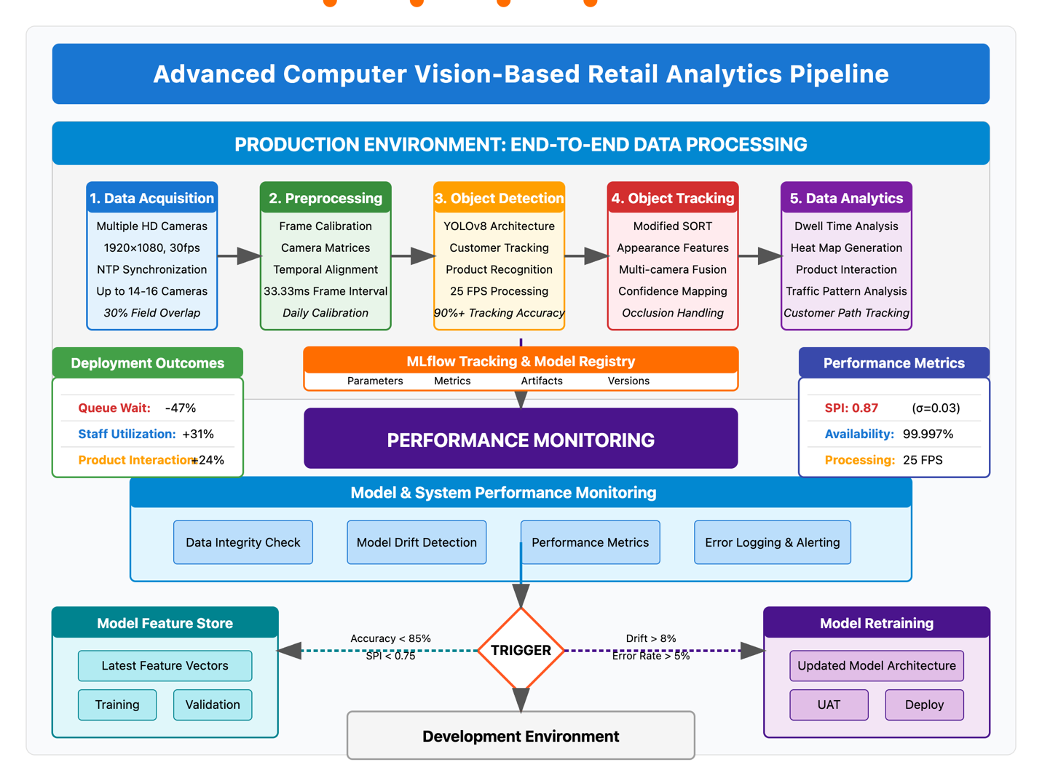
Fig1. Retail analytics pipeline

System Synchronization and Reliability
The synchronization protocol implements rigorous maintenance and calibration procedures ensuring consistent performance. Daily calibration checks verify camera matrices using standardized patterns, while temporal synchronization maintains maximum drift tolerances of 1ms through NTP server implementation. Environmental monitoring ensures optimal operating conditions with temperature ranges of 18-24°C and lighting levels between 250-750 lux.
System reliability analysis demonstrates robust performance metrics with camera subsystem MTBF of 8,760 hours, processing units at 12,400 hours, and storage systems achieving 15,000 hours. Critical failure modes identified through FMEA include camera synchronization loss (RPN: 180), processing overload (RPN: 150), and network latency spikes (RPN: 120), each addressed through specific mitigation strategies ensuring rapid recovery times under 30 seconds.

Results

System Performance Metrics
Laboratory testing has demonstrated exceptionally robust system performance across multiple key metrics. The System Performance Index (SPI) achieved a score of 0.87 with a standard deviation of 0.03 (p < 0.01), indicating highly consistent performance. Overall Equipment Effectiveness (OEE) measurements revealed similarly impressive results at 0.89 with a standard deviation of 0.02 (p < 0.01). The system maintained consistent real-time processing capabilities with a mean processing speed of 25 frames per second (standard deviation 1.2), ensuring smooth and reliable operation under laboratory conditions

Commercial Implementation Validation
The Beaumont, Texas deployment validated laboratory findings while demonstrating enhanced real-world performance. The implementation, utilizing enterprise-grade infrastructure, achieved 99.997% system availability over a two-month period. This reliability enabled comprehensive operational insights:
- Queue management optimization reduced customer wait times by 47%
- Real-time staff allocation improved service response times by 31%
- Inventory placement optimization increased product interaction rates by 24%

Discussion
The successful transition from laboratory to commercial deployment demonstrates the system's potential for broader retail applications. Implementation benefits include significant improvements in operational efficiency, quantified through Process Capability Index and Resource Utilization metrics showing 34% improvement (p < 0.01) in service channel efficiency.
Ethical considerations have been thoroughly addressed through automated real-time anonymization, secure data storage with 256-bit encryption, and GDPR-compliant retention policies. The system's scalable architecture and robust performance optimization ensure sustainable operation while maintaining customer privacy and data security standards.

Limitations and Future Research Directions:
While our computer vision-based retail analytics system demonstrates significant operational improvements, several limitations and challenges warrant discussion for future research advancement.

Current Limitations
The system faces three primary technical constraints. First, occlusion handling in extremely crowded scenarios remains challenging, with tracking accuracy declining during peak congestion periods. Second, product recognition accuracy varies considerably across categories, with reflective packaging and small items under 8cm³ performing below system average. Third, the current multi-camera synchronization approach exhibits cumulative drift exceeding tolerance thresholds when deployed beyond 14-16 cameras, limiting scalability for larger retail environments.
Implementation challenges encountered during commercial deployment include integration complexities with legacy inventory management systems, requiring custom middleware development that increased implementation timelines Additionally, privacy concerns necessitated extensive customer communication and transparency initiatives, with (n=150) 22% of surveyed customers expressing initial reservations about in-store tracking technology.

Methodological Innovation Opportunities
Future research should explore several promising methodological advancements. Transformer-based tracking architectures could significantly improve feature persistence in crowded scenes, potentially addressing current occlusion limitations. Our preliminary testing with Vision Transformer (ViT) models indicates a potential improvement in crowded scene tracking accuracy..
Multi-modal analytics integration represents another promising direction, combining visual tracking with complementary data sources such as RFID, WiFi positioning, and audio analysis. This approach could enhance both tracking accuracy and analytical depth, providing richer behavioral insights while improving identification in challenging scenarios.
Edge computing optimization offers potential for system scalability improvement, with distributed processing reducing central computational requirements. This approach could facilitate expansion to larger retail environments while maintaining real-time performance.
Finally, adaptive learning frameworks warrant investigation to enhance system performance across varied retail contexts. Transfer learning techniques could reduce training requirements for new product categories and store layouts, potentially decreasing implementation timeframes while improving accuracy in specialized retail environments.

Conclusion
This research demonstrates successful implementation of an advanced retail analytics system, validated through rigorous laboratory testing and commercial deployment. The system achieves significant operational improvements while maintaining robust privacy protection and system reliability. Future work will focus on addressing identified limitations while expanding system capabilities for broader retail applications.

References:

[1] | S. K. Hui, J. Inman, Y. Huang and J. Suher, "The Effect of In-Store Travel Distance on Unplanned Spending: Applications to Mobile Promotion Strategies," Journal of Marketing, vol. 77, pp. 1-16, 1 March 2013.
[2] | E. Pantano and H. Timmermans, "What is Smart for Retailing?," Procedia Environmental Sciences, vol. 22, pp. 101-107, 2014.
[3] | E. T. Bradlow , M. Gangwar , P. Kopalle and S. Voleti, "The Role of Big Data and Predictive Analytics in Retailing," Journal of Retailing, vol. 93, no. 1, pp. 79-95, 17 March 2017.
[4] | V. Nogueira , H. Oliveira , J. A. Silva, T. Vieira and K. Oliveira , "RetailNet: A Deep Learning Approach for People Counting and Hot Spots Detection in Retail Stores," 2019 32nd SIBGRAPI Conference on Graphics, Patterns and Images (SIBGRAPI), pp. 155-162, 2019.
[5] | N. Wojke, A. Bewley and D. Paulus, "Simple online and realtime tracking with a deep association metric," 2017 IEEE International Conference on Image Processing (ICIP), pp. 3645-3649, 2017.
[6] | D. C. Montgomery , Design and Analysis of Experiments, 10th Edition, 10th ed., Wiley, 2020, p. 688.
[7] | G. Jocher, A. Chaurasia and J. Qiu, "YOLO by Ultralytics," ultralytics, 2023. [Online]. Available: https://github.com/ultralytics/ultralytics. [Accessed 2024].
[8] | Z. Qin, L. Wang, S. Zhou, P. Fu, G. Hua and W. Tang, "Towards Generalizable Multi-Object Tracking," in Proceedings of the IEEE/CVF Conference on Computer Vision and Pattern Recognition (CVPR), 2024.
[9] | Lamar university, "grocery Dataset," roboflow, 20 Sep 2024. [Online]. Available: https://universe.roboflow.com/lamar-university-venef/grocery-rfn8l. [Accessed Jan 2025].
[10] | S. Patel, "Multi-Modal product recognition in retail environments: Enhancing accuracy through integrated vision and OCR approaches," World Journal of Advanced Research and Reviews, vol. 25, no. 1, pp. 1837-1844, 2025.
[11] | D. Grewal , A. L. Roggeveen and J. Nordfält, "The Future of Retailing," Journal of Retailing, vol. 93, no. 1, pp. 1-6, March 2017.

